***Somali Community - Focus Group Results***

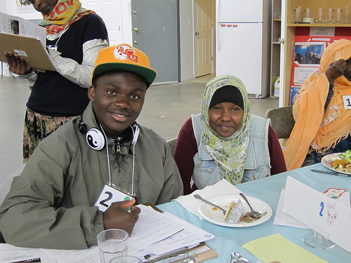A focus group with Somali residents was conducted with the assistance of Somali Community Services of Seattle on May 13, 2013. This was part of the *Information Technology Access and Adoption in Seattle: Progress towards digital opportunity and equity* study conducted by the City of Seattle. Sixteen individuals attended the focus group, in addition to four bilingual note-takers/ table facilitators, and a bilingual facilitator. Sixteen participants completed at least part of a brief written survey. Participants engaged in planned focus group activities – including a dynamic method that relies on *mutual interviewing* among the community members – and did so with evident interest and engagement.

**Table 1. Group demographic description**

|  |  |
| --- | --- |
|  | Percentage |
| % men | 62% |
| Education |  |
| Less than high school | 39% |
| HS grad/GED | 15% |
| Some college/AA/AS | 39% |
| BA/BS | 8% |
| Age |  |
| 18-25 | 25% |
| 26-35 | 25% |
| 36-50 | 13% |
| 51-64 | 13% |
| 65 or older | 25% |
| Employment |  |
| Employed | 39% |
| Retired | 23% |
| Student | 8% |
| Unemployed | 39% |
| Income |  |
| <$20,000 | 92% |
| $20K-$30K | 8% |

Table 1 summarizes the demographic distribution of the participants. Most of the participants are men. Education produced an unusual, bimodal, distribution, with two concentrations of education levels - 39% with less than a high school education, and the same percentage with some college. Further analysis shows that nearly all of those with less than a high school education are women, and nearly all of those with some college or a two year degree are men. A wide range of ages was represented, with half 35 or younger, and a quarter 65 or older. Even though 39% reported being employed (and the same percentage was unemployed), annual household incomes are almost uniformly low.

Two challenges emerged in conducting this focus group that occurred in none of the others: 1) the low level of education increased the amount of time needed for activities that involved writing, and 2) the flow of people coming in and moving between tables resulted in less time spent in interviewing. Some of the lower literacy participants paired up with other participants or table facilitators to help with interviewing and scribing. As a result, it was not possible to gather as much information as anticipated. In the future, it would be beneficial to schedule a group with this community for four hours instead of two, and build in time for a break, especially if the day of the group is a day of fasting for the participants. Additionally, it would be important to ascertain in advance the level of literacy support needed by the participants, and prepare accommodations, such as recruiting additional scribes or scheduling enough time for table facilitators to gather and record findings at the end of each interview round.

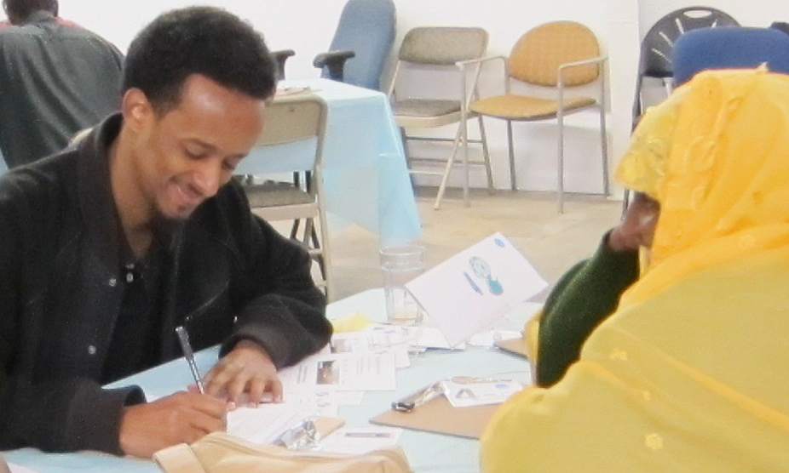**Summary**

This group ranged in age and education. Older participants were less likely to have formal education, especially the women. Nevertheless, in this focus group as in the others, most participants use computers, and half use the Internet, via mobile or public access for many. Whether or not they are currently computer users, most are interested in using technology, appreciate the benefits it offers (especially information and communication), and want to learn how to use computers, or if they already know how, they want to learn more. At the same time, participants greatly appreciate face-to-face contact with friends, and also when communicating with government. Some note that as more communication is conducted via the Internet, non-technology users may become more and more isolated. At the same time, others voiced concerns that too much reliance on technology for communication and for other daily tasks will itself, similar as isolation, lead to negative interpersonal outcomes.

The barriers to computer use are significant for this community and, while they impact both men and women, the women's lower level of education may produce disproportional impacts. As in other groups we have heard from, just the cost of a computer, especially together with the cost of Internet access, results in significant barriers to use, given the low incomes of participants. Additionally, participants don't trust the Internet price not to go up after they are under contract. Thus, public access to computers and the Internet is *especially important* for these individuals. However, limited or no English skills is another barrier even to learning to use technology; together, the high cost and the low English skills contribute to levels of computer literacy that, for many, may be difficult to remedy. The road to computer literacy is even more difficult for those who, as was evident in this group, cannot read or write even in their first language. Participants say these members of their community, almost all elderly, rely on younger relatives for help.

Younger community members are facile with technology, make do with the access they have, which for many is a smart phone with a data plan - or with wi-fi access. One young participant said she uses her smart phone to do her homework, typing Word documents on her phone. Without home or cell phone access, other students spend more time at the library.

The community centers, like Somali Community Services of Seattle, the hosting organization, are important for this community in that they provide computer and Internet access for community members with or without home access; and serve as an information conduit between community members and the government, disseminating information to community members (and helping community members understand the material they receive in English), and reporting back community perspectives to their government representatives.

About half use email and about half use Facebook (though no more than one-third check either daily). About half of those who don't use Facebook would like to learn, though as with other groups, participants expressed concern about inadequate protection of privacy when using the Internet, particularly at very high speeds or in communication with government.

**Technology Access and Use**

**What is needed to use computers:**

* She used to have it then it broke so now she's about to buy a new one
* She doesn't know where to go to use one for free
* Most people are worried about the high cost of Internet. It's $15 at first, then up, up, up - it's American business.
* Lack of formal education in her own language. [Computers] require the ability to read and write... if they've never had education, it's a long education path. If everything becomes Internet, how are we going to use it? Most people in my community have no idea about Internet, how to use computers - mostly seniors.
* We've been hearing about a big divide for 15 years. And my community is still here.

*Survey* responses show that the large majority of participants (81%) have a cell phone - and about one-third of participants use a smart phone (though only 20% of participants say they *own* a smart phone. One woman commented that she sometimes uses her son's smart phone). Almost half (43%) use texting. Only 19% reported having a landline.

Half have a computer at home (including a laptop for 37% and a tablet for 19%) and 31% have Internet access at home. Significantly for public policy, only 25% said they have home Internet for their computer; the others indicated mobile access. Participants noted that the Internet is too expensive and the speed is very slow. Twenty-nine percent use wi-fi. Of those who have home Internet access, 22% get it through the cable company, one-third get it through DSL, and 44% get it through a data plan for their cell phone or tablet. One young participant says her access is by smart phone, which she uses to do her homework. She even types Word documents on her phone.

Eighty percent say they use computers, and half say they use the Internet. *Mutual interviewing* provided additional details about barriers to additional Internet use in this population. Many lack formal education and may not be able to read or write. And even many those who are able to read and write lack basic computer skills - even if they have computer access. Those without home Internet access would like to have access or know about it but don't know how to use it, don't have a working computer at home, or find Internet access unaffordable - if not at first, then after they've taken on a contract. "It's American business." One person mentioned not knowing where to go to use a public access computer. In general, participants - especially the young people - are concerned about their privacy and identity theft. Others expressed concern about children exposed to too much information or inappropriate materials.

This group selected an average of four uses for computers and the Internet, illustrated in Figure 1. Apparently some use is second hand (again, a pattern we saw in other immigrant communities): even some who said they don't use computers or the Internet identified some uses. Participants use the Internet primarily for getting information, especially community information, and to watch TV or attend a class or webinar.

**Using computers and the Internet**

* I watch my favorite movies; I do my homework in there
* To communicate with the world, e.g. doctors, banks, education
* [Seniors] connect with younger family members. My mom knows nothing about computers and has 10 kids. We help her. I don't know what she'd do without us.
* People without computer access become more and more isolated.

Interviewers asked what their interviewees liked (or would like) best about using computers and the Internet. Some mentioned communication - with friends and relations, or more broadly, "with the world," including doctors and banks. Others mentioned education, including doing homework, or watching BBC. Interestingly, some opined that those without access will become increasingly isolated, unable to communicate easily wither others, while at least some of those without access expressed concern that too much access would interfere with interpersonal relations, “turning people into machines.”

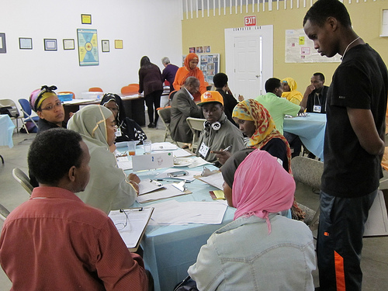Figure 2 shows where computer-users use computers and the Internet. Most (62%) use computers at home, and even more use them at the community technology center, a resource for about two-thirds of these respondents. The library is also a very important resource. If students have Internet access at home, they can do their homework; otherwise, they must go to the library. Note that, taken together, nearly all (92%) of the respondents use computers at the library, a friend’s or relative’s, a community technology center or a café or restaurant, even if they have access at home. Half of those with home access also use computers at all four of these other locations.

When asked about their satisfaction with their home Internet service, about two-thirds (63%) were satisfied with the company's customer service, but only 45% each were satisfied with the cost and the speed, and only 30% were satisfied with their Internet service's reliability. When asked what one thing would most improve their cable service, 91% said “price.” About two-thirds checked "speed,” and almost half selected "reliability." Only 9% chose “customer service.”

When asked how much they would pay for service or for faster service, responses ranged from "Nothing" (21%) to between $10 and $20 (57%). The other 21% selected amounts in between.

About a quarter (27%), mostly men, rated their skill with computers above the scale’s midpoint and 40% (mostly women) rated themselves below it, with one-third selecting “none” or “not very” skilled. Another one-third selected the scale's mid-point.

Respondents were asked what they thought prevented people in their community from using computers or the Internet. Figure 3 shows that most answers related to cost - of the equipment, or of Internet service.

**High Speed Internet**

**High Speed Internet**

* I wish the fact that I would be able to utilize such services.
* Yes, if I have high speed Internet I would love it. Doctor's appointments, home security, do my homework, news, call back home, home business.
* Keep an eye on my kids, communicate, doctor's appointment, home school online.
* No socializing, become machine, not human. Not healthy - I want to see my friend.
* Personal data, privacy, too much noise - I lose the attention of school.
* My group wants to see people face-to-face.

After City representative talked about the potential and possible availability of super high speed Internet in Seattle, some of the participants discussed the pros and cons in some detail.

All respondents were interested in trying super high speed Internet. All were interested in using the service for education - to help with homework, or to take an online class. Specific interest was shown in taking an ESL class online, in the potential for improved communication, in attending medical appointments from home, in keeping an eye on things at home, and in online shopping, especially for groceries.

Concerns also arose from *all* the respondents who currently use computers, including the potential cost of the service, the lack of computer literacy in their communities, the lack of interpersonal contact and decrease in physical exercise, likely threats to privacy ("all the information. How will they use it?"), and the great potential for distraction. One mentioned the "online dream" which we interpret as too great a focus on a virtual reality, possibly at the expense of day-to-day physical life.

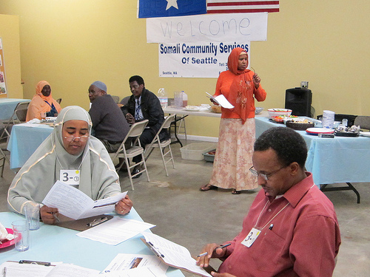**Cable TV and Video Content**

None of these participants indicated that they subscribe to cable TV, though a few rated their satisfaction with aspects of cable service, perhaps thinking of service they had in the past, reasons they don't have service, or service that others have. Of these, half were satisfied with the customer service, and 40% each with cable's reliability and cost, and all indicated that a better price is the one thing that would most improve their cable service.

Respondents gave a range of answers when asked to rank how they prefer to watch TV programs or movies. Cable TV was ranked first slightly more often than free TV (25%, 19%), followed by over the Internet using sources such as Netflix and Hulu (13%) and satellite (6%). When the second and third choices are added in, 56% chose cable, and 44% each free TV and over the Internet. Again, it is confusing that none indicated that they subscribe to cable, yet it is the preferred way of watching TV for moving for about half. This could reflect the way the question was asked (what is preferred vs. what is the behavior), or it could reflect watching cable programs away from home.

**Social media**

* I don't use it. I don't know how to use it but I want to learn.
* I never learned and now I am too old to learn.
* My six children were raised here - they are always texting and on technology.

**Social media and government**

* I don't like it because I never learned how to read and then how am I going to learn only in a little time. We need time and some of us we will never get [there]. If everything become Internet then elder people like me will never have a chance.
* If I stay long, I will learn because we have to

**Seattle.gov and The Seattle Channel**

About one-third of these participants have visited Seattle.gov and only 19% have seen the Seattle Channel, all on cable.

In *mutual interviewing* some participants said they would visit the website *if they knew how* to and that they'd like to be more aware of government services. One person would like it to be easier to navigate around the website.

**Social Media**

About one-third of survey respondents report that they check email daily, and about half don't use email at all (31%) or didn't respond to the question (25%). Nearly half (43%) use attachments with email.

Mutual interviewing and the survey both show that many in this community use social media (mostly Facebook, some Twitter). Some use it daily, some less so and at least half of those that don't use it would do so if they knew how.

Respondents use social media for a variety of reasons, including:

* communicating with other people
* looking for work
* finding information and services

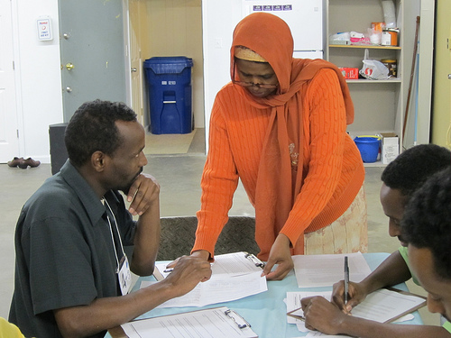The potential of using these methods to communicate with government was evident, both for getting information and giving feedback, though concerns about privacy, about the importance of face-to-face communication, and about illiteracy in the community were evident as well.

**Communication with the City**

* I would come to Somali Community and they would be my voice. We don't speak English.
* When they receive a letter from the government and can't read or write, so they come here.
* I would call them, email them. I would also write letters to them.
* To get more resources to Somali Community, hire employees at Somali Community, bring people together.
* Email back
* I had to go far to help someone. It would be better if I could use a video link...I did some work over the phone with a lawyer. If it were with video, that would be better.

**Communicating with Government**

Participants said they feel that communication with the government is especially important because of the need to know if a law has changed. As a group, they remarked that they value face-to-face communication, though many also appreciate the convenience of the Internet. The survey offered a series of checkboxes with different ways respondents might give opinions to the City. Participants selected an average of 4 strategies for giving their opinions, and very few said they did not want to do so.

Figure 4 shows again ­that personal contact is *very important* to this group with almost two-thirds of the participants selecting “community meeting,” followed by nearly one half selecting "in person focus group." Nearly one half said they'd like to respond to a telephone survey and not quite as many (38%) selected an online survey or one by email.

While other non-English-speaking groups urged the City to remember to provide information in their language, these Somali participants accommodate the language barrier by relying on their community organization. This could be due in part to the high rate of illiteracy in this group, and in any case suggests that the City seek ways to supplement written information using both translation and graphics.

C:\Users\PC User\Documents\Dropbox\active\Jobs\COS Tech 2012\focus groups\somali\Somali04.tiffInterviewee suggestions for how the City could more effectively provide information, and make it easier for residents to participate in improving their communities, included calls for more activities that bring people together, and specified the value in bringing Somalis together with people from the City through outreach. They also want to be sure that their community organization has the resources to continue its work.

When asked how they *prefer* to make contact with the city, "email" and "in person" were the most popular responses, selected by half of the respondents, followed by "telephone" and "writing a letter" (40%). Texting, Facebook and Twitter received fewer responses.

Asked how they would like to get information *from* the City, as illustrated in Figure 5, the most frequent choice for this group is via "Other community members" (62%), which during mutual interviewing seemed especially to refer to community organizations, such as Somali Community Services of Seattle. Participants explained that there are multiple different community centers that serve different neighborhoods. About half selected the TV news (46%), followed by receiving texts (38%). Combined, about one-third selected Internet-based strategies (email, Facebook, and the City's website. Some mentioned using placards in busses to get the word out.

**Learning**

Only one person said his skills are "OK with computers." In *mutual interviewing*, three-fourths of the participants asked for help learning to use computers, or learning more computer programs. Another asked to learn about what's happening in the City, including City programs, news, and events perhaps via computers or possibly using other methods to get the word out. *All* would like computer and Internet classes, though one asked for individual training first. About half named individual training as well as classes and about 40% would appreciate short workshops as well. A training video was mentioned by one person.

**Need to learn**

* Most of the community came from a war-torn country. They need classes to learn about computers and enhance knowledge.
* The lab here is useful, but there aren't that many computers here.

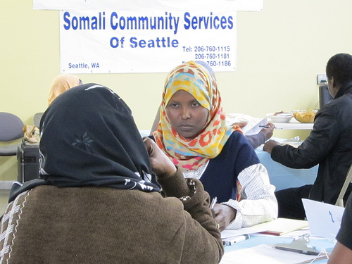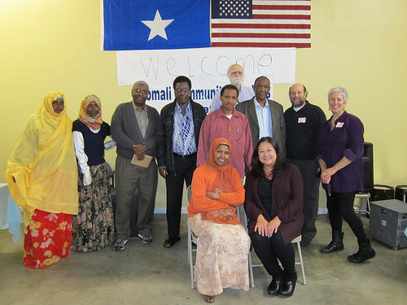

|  |  |
| --- | --- |
|  | See the full report with other focus groups and survey results at Seattle.gov/tech/indicators   City of Seattle Department of Information Technology  Community Technology Program |